Day 3 API Integration & Data Migration

[Alishba E-commerce]

***API Integration Overview***

● API Name: The external marketplace API, hosted at: https://next-ecommerce-template-4.vercel.app/api/product.

● Data Fetched:

○ Products: Details such as product titles, prices, descriptions, categories (e.g., sofas, chairs), images, etc.

○ Categories: Furniture categories like "Sofas" "chairs”, etc., associated with products.

● Sanity Client: Used to manage and store fetched data in the CMS, ensuring compatibility with the defined schema structure 3. Schema Structure Changes The product schema was enhanced to better represent furniture product details. Key updates include.

***Snippet of Updated Product Schema:***

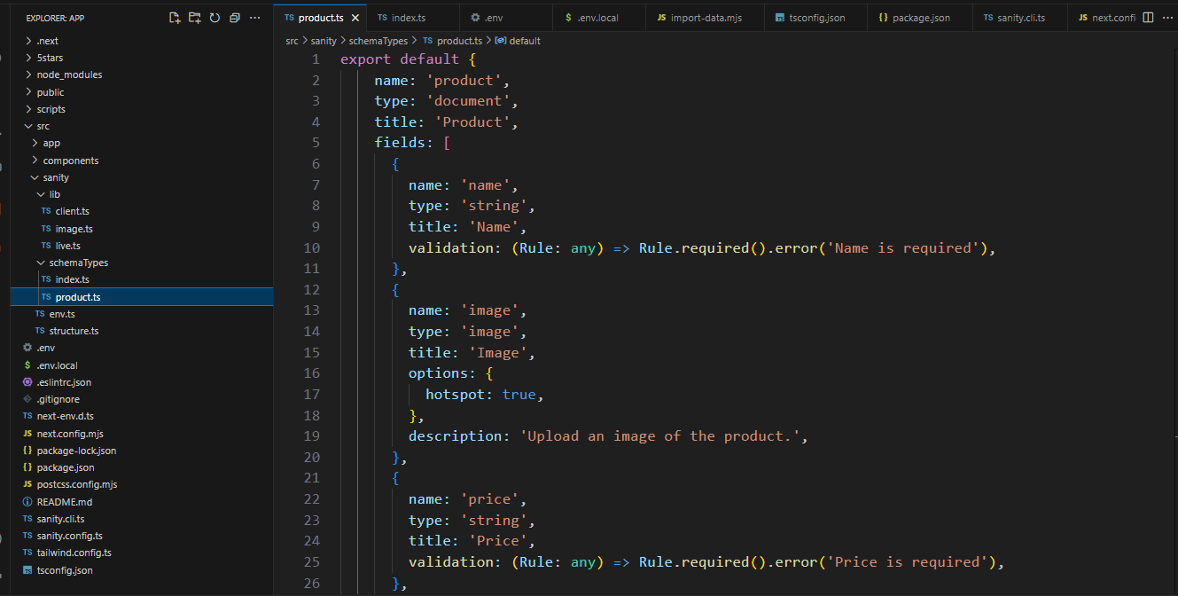

**3. Fetch Data from API:**

.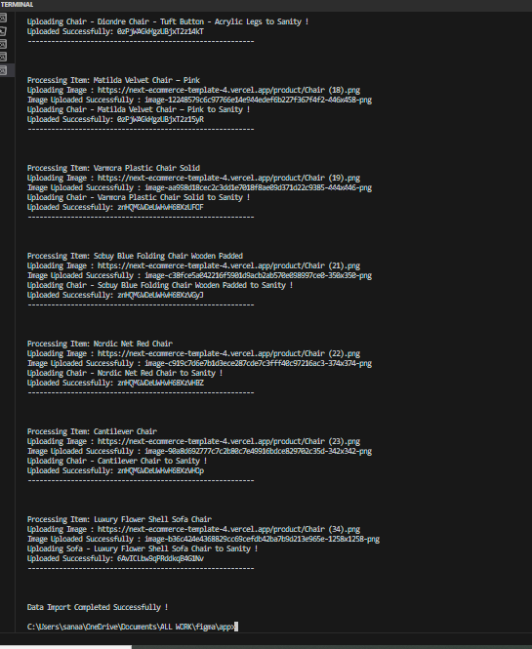

***Migration Steps and Tools Used :***

Tools Used:

1. Sanity Client: To interact with the Sanity CMS (via @sanity/client).

2. Node.js & Fetch API: For fetching data from the API and uploading it to Sanity.

3. Environment Variables: For secure storage of sensitive data like API tokens.

4. Sanity Image Tool: To upload and manage furniture images in the CMS.

Migration Steps:

1. Set Up Environment:

○ Installed required dependencies: @sanity/client

○ Configured .env.local for secure storage of API keys.

2. Sanity Client Setup:

○ Created a sanityClient instance using project ID, dataset, and API token.

**Code Snippets for DataMigration from**

**API to Sanity:**

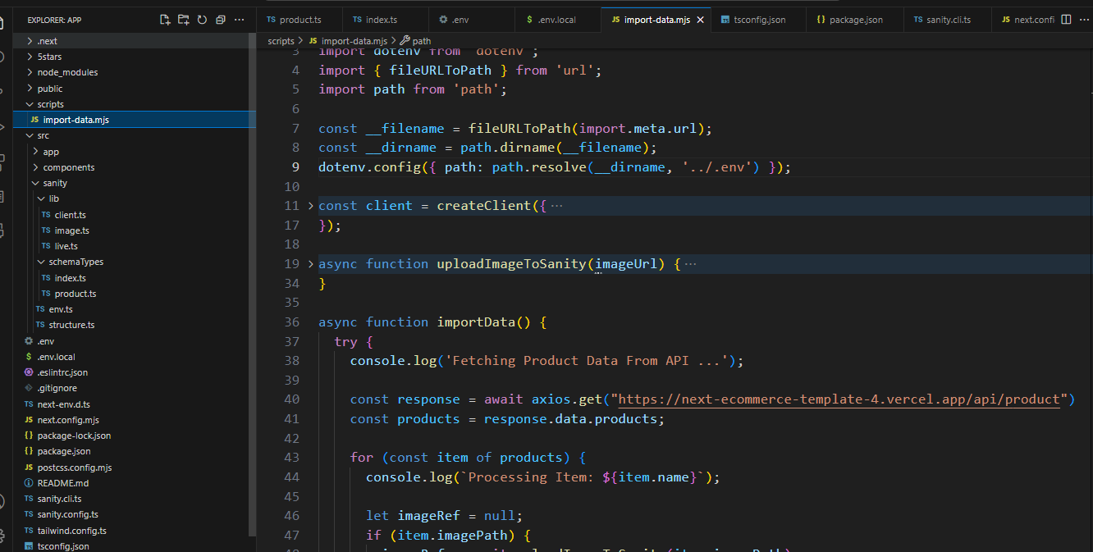

***Upload Images to Sanity:***

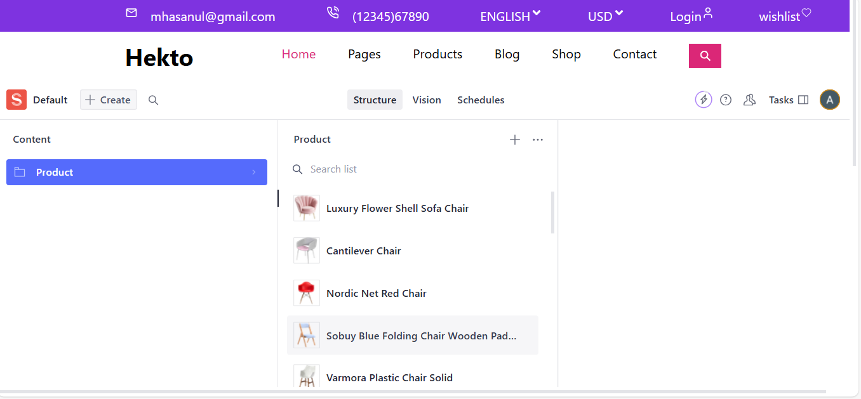

**Code Snippet To display data on Frontend:**

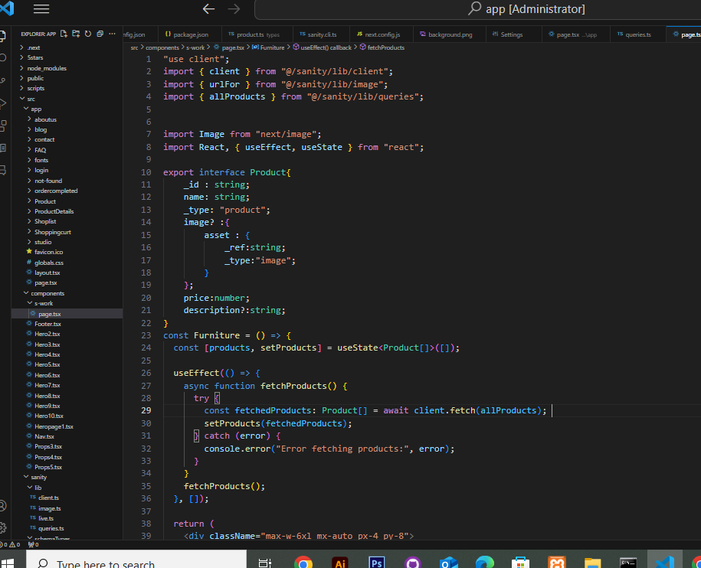

***Data successfully display in Frontend***

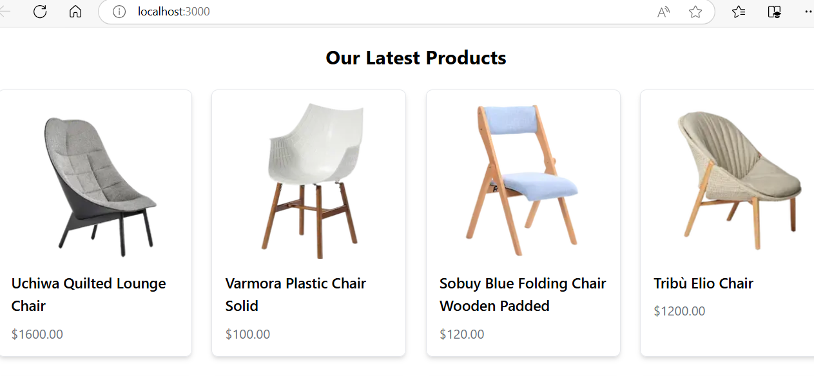

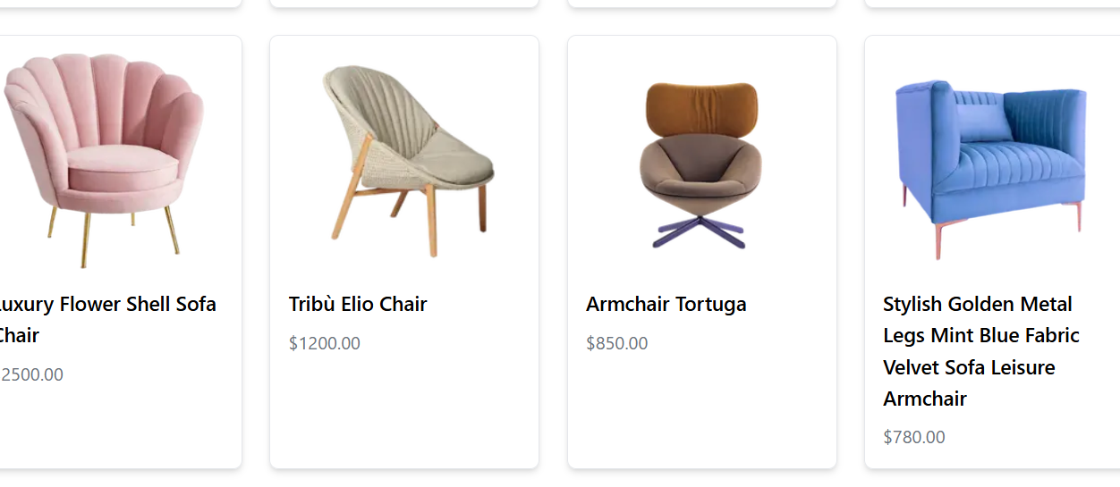

***By :Alishba***

***GIAIC Student***